

**TOORO PARENTS EDUCATION CENTRE**

**PRIMARY SEVEN SET ONE TERM 2 2020**

**BASIC SCIENCE AND HEALTH EDUCATION**

***Time allowed: 2 hours 15 minutes***

**Name: ______________________________________________________________**

**School: _____________________________________________________________**

**FOR EXAMINER’S USE ONLY**

**Read the following instructions carefully:**

1. The paper has **two** sections: **A** and **B**
2. Section **A** has 40 questions (40 marks)

**FOR EXAMINER’S USE ONLY**

|  |  |  |
| --- | --- | --- |
| **Qn. No** | **MARK** | **SIGN** |
| **1 – 10** |  |  |
| **11 – 20** |  |  |
| **21 – 30** |  |  |
| **31 – 40** |  |  |
| **41 – 43** |  |  |
| **44 – 46** |  |  |
| **47 – 49** |  |  |
| **50 – 52** |  |  |
| **53 – 55** |  |  |
| **TOTAL** |  |  |

1. Section **B** has 15 questions (60 marks)
2. Answer **ALL** questions. All answers to both Sections **A**

and **B** must be written in the spaces provided.

1. All answers must be written using a blue or black ball

point pen or ink. Diagrams should be drawn in pencil.

1. Unnecessary crossing of work may lead to loss of marks.
2. Any handwriting that cannot be easily read may lead to

loss of marks.

1. Do **not** fill anything in the boxes indicated;

For Examiner’s use only.

***Turn over***

**SECTION A (40 MARKS)**

1. Give one health habit one should practice to avoid food contamination.

_____________________________________________________________________

2. Which body organ does Hepatitis affect?

_____________________________________________________________________

3. Give any one example of a fossil fuel.

_____________________________________________________________________

4. Besides being vertebrate, how else are birds similar to mammals?

_____________________________________________________________________

5. Why is it necessary to drain stagnant water around a home?

_____________________________________________________________________

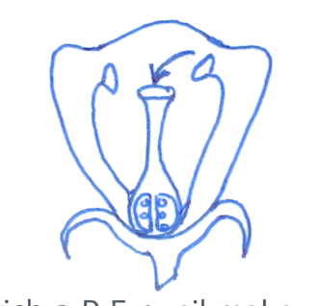6. On the diagram below, label with letter x the part that produces pollen grains.

7. Apart from capital, give one other requirement for starting a livestock farm?

_____________________________________________________________________

8. Identify one accident that requires the use of splints in giving first aid.

_____________________________________________________________________

9. Give one exotic breed of goat reared for milk production.

_____________________________________________________________________

10. Name the energy resource obtained from animal dung and urine.

_____________________________________________________________________

11. State one way of reducing echoes in a hall.

_____________________________________________________________________

12. Give one reason why we use toothpaste for brushing teeth.

_____________________________________________________________________

13. Draw and name any one example of a magnet.

_____________________________________________________________________

14. Give one disadvantage of free range system of poultry.

_____________________________________________________________________

15. Identify one condition in babies that causes dry lips and a sunken soft spot on the head.

_____________________________________________________________________

16. Why are animals grouped under renewable resources?

_____________________________________________________________________

17. Which mineral salt is necessary for the formation of red blood cells in people?

_____________________________________________________________________

18. Apart from melting, state any one other physical change that takes place in the presence of

heat.

_____________________________________________________________________

19. Name the disease that affect both rabbits and poultry.

_____________________________________________________________________

20. Why does oil settle on top when mixed with water?

_____________________________________________________________________

21. Give one example of excretory systems

_____________________________________________________________________

22. In which method of making water clean do you first allow the impurities to settle at the

bottom of the container?

_____________________________________________________________________

23. State the piece of advice given to a person who suffers constipation.

_____________________________________________________________________

24. Why is maize grouped under monocotyledonous plants?

_____________________________________________________________________

25. How is the function of the pulmonary artery different from that of other arteries?

_____________________________________________________________________

_____________________________________________________________________

26. Which property of air enables you to drink soda using a straw?

_____________________________________________________________________

27. What name is given to disease caused due to lack of a certain food value in one’s diet?

_____________________________________________________________________

28. State one way in which married couples can avoid HIV/AIDS among themselves.

_____________________________________________________________________

29. In which way is the use of solar energy good to our environment?

_____________________________________________________________________

30. Which body system help to remove harmful waste products produced by the body cells?

_____________________________________________________________________

31. In which way can a donkey be used as an energy resource?

_____________________________________________________________________

32. What is a joint?

_____________________________________________________________________

_____________________________________________________________________

33. Mention one PIASCY message.

_____________________________________________________________________

34. Why is a pregnant woman said to be a vulnerable person?

_____________________________________________________________________

35. Which element of PHC promotes quick recovery?

_____________________________________________________________________

36. Describe one importance of a school health parade.

_____________________________________________________________________

37. Which component of soil is needed by plants to make food?

_____________________________________________________________________

38. State one similarity between a housefly and a fresh water snail.

_____________________________________________________________________

39. Which force enables us to walk?

_____________________________________________________________________

40. Give one secondary sex characteristic in boys.

_____________________________________________________________________

**SECTION B (60 MARKS)**

41. a) Which term refers to a sudden happening that results into injury or death?

_____________________________________________________________________

b) Give two examples of (a) above.

i) _________________________________ ii) _____________________________

c) State any one quality of a good first aider.

_____________________________________________________________________

42. a) Name one exotic breed of cattle purposely reared for;

i) beef production ____________________________________________________

ii) milk production _____________________________________________________

b) State one way you can identify a beef breed from a dairy breed.

_____________________________________________________________________

c) Apart from beef and milk production, how else are cattle useful to people?

_____________________________________________________________________

43. a) What is seed dispersal?

____________________________________________________________________

_____________________________________________________________________

b) Name any two agents of seed dispersal.

i) _________________________________ ii) _____________________________

c) State one advantage of seed dispersal in the environment.

_____________________________________________________________________

44. The table below shows joint and their position in the human body. Study it and complete it

correctly.

**Joint Position in the body**

Pivot joint ________________________

______________________ shoulder

______________________ knee

Suture joint _______________________

45. a) Primary Five pupils were given two objects i.e an apple and a brick. Which method

would the pupils apply to find the volume of each.

1. an apple __________________________________________________________
2. a brick ___________________________________________________________

b) Name any equipment the pupils needed to have to find the volume of an apple.

_____________________________________________________________________

c) If the brick had a mass of 120gm and a density of 5gm/cc, what volume did they pupils

get?

## 

_____________________________________________________________________

46. The diagram below shows the alimentary canal of man. Study it carefully and answer

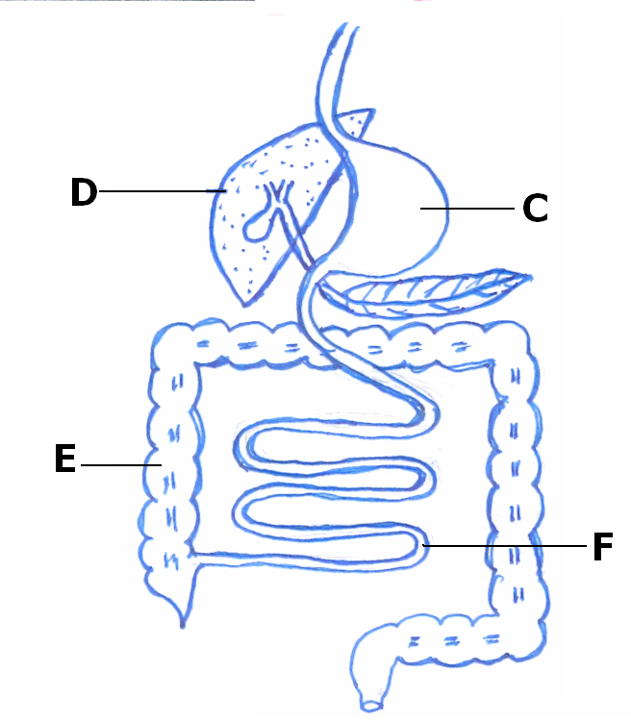questions that follow.

B

a) Name the parts labelled D and F.

i) D _____________________________ ii) F ___________________________

b) Mention the digestive juice produced by B.

____________________________________________________________________

c) Why does digestion of food end in part F?

____________________________________________________________________

47. a) State any two differences between a housefly and a spider.

i) ________________________________________________________________

ii) ________________________________________________________________

b) Give one similarity between a housefly and a spider.

_____________________________________________________________________

c) Mention one disease spread by a housefly in people.

_____________________________________________________________________

48. a) Blood is a liquid tissue found in the body of most animals. Name any one component of

blood.

_____________________________________________________________________

1. Give at least two functions of blood in the human body.

i) ________________________________________________________________

ii) ________________________________________________________________

c) In the space below, draw and name the shape of any blood cell.

49. a) Write STD in full.

_____________________________________________________________________

b) Give any one example of STDs caused by bacteria.

_____________________________________________________________________

c) Suggest any two dangers of premarital sex.

i) ________________________________________________________________

ii) ________________________________________________________________

50. a) State one danger of taking drugs without a medical workers instructional.

_____________________________________________________________________

b) Mention any two useful pieces of information written by a medical worker on a

prescription sheet given to a patient.

i) _________________________________ ii) _____________________________

c) Give any one reason why people take medical drugs.

_____________________________________________________________________

51. a) Give one way in which Primary Health Care(PHC) is a promoted in a family.

_____________________________________________________________________

b) State one way PHC is promoted by each of the following;

i) individuals ________________________________________________________

ii) community ________________________________________________________

c) Mention one role of a school health committee.

_____________________________________________________________________

52. a) What type of change takes place when a knife rust?

_____________________________________________________________________

b) Give two conditions necessary for rusting to take place in a knife.

i) _________________________________ ii) _____________________________

c) State any one effect of rusting on a knife.

_____________________________________________________________________

53. Match the source of energy to the type of electricity produced.

**Source Type of electricity**

flowing water solar electricity

hot springs thermal electricity

burning of coal hydro electricity

the sun for thermal electricity

i) flowing water __________________________________________________

ii) hot springs __________________________________________________

iii) burning of coal __________________________________________________

iv) the sun __________________________________________________

54. a) What is sound? ____________________________________________________

_____________________________________________________________________

b) John was hitting a drum 10m away from where Tom was sitting. How was Tom able to

hear the sound of the drum?

_____________________________________________________________________

c) How does a drum produce sound?

_____________________________________________________________________

d) Give any one natural source of sound.

_____________________________________________________________________

55. Name one example of a disease people are likely to get under the following condition.

i) poor disposal of faeces _______________________________________________

ii) poor feeding ______________________________________________________

1. having unprotected sex ______________________________________________
2. poor personal hygiene _______________________________________________

***Good luck!***